Program source:

STM32Cube_FW_H7_V1.5.0\Projects\STM32H747I-EVAL\Examples\QSPI\QSPI_MemoryMappedDual

Function:

QSPI Flash read and write test program, the program remaps the running address of QSPI Flash to the location of 0x90000000.

Test Methods:

1. Select the M4 kernel configuration as shown below and click the LOAD button to download the M4 kernel program.

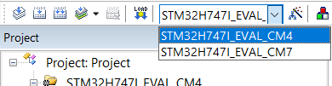

1. Click the image below to select the M7 core configuration and click the LOAD button to download the M7 core program.

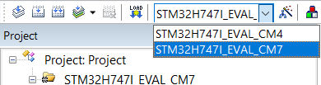

1. After the program runs, the data in the aTxBuffer is written to the external QSPI Flash. After the data is written, the space of the QSPI Flash is remapped to the location of 0x90000000 and used as a memory. The program compares the written content through memory comparison. If the data is correct, the LED will light up.